Latest Lodge Tyre store now fully open in Sheffield

Lodge Tyre Co Ltd are delighted to announce their latest store in South Yorkshire is now fully functional. Located just off Junction 34 of the M1, and servicing the major conurbations of Sheffield and Rotherham, the 6000 sq ft hub and fleet of modern commercial fitting vans is perfectly placed to provide the quality service and fast response demanded by our exacting customers. Backed up by our 24-7 industry leading Call Centre based in Stafford and supported by other local stores in places like Chesterfield, Retford and Rochdale, we are here to service your fleet, minimize your downtime and offer great service at a great price.
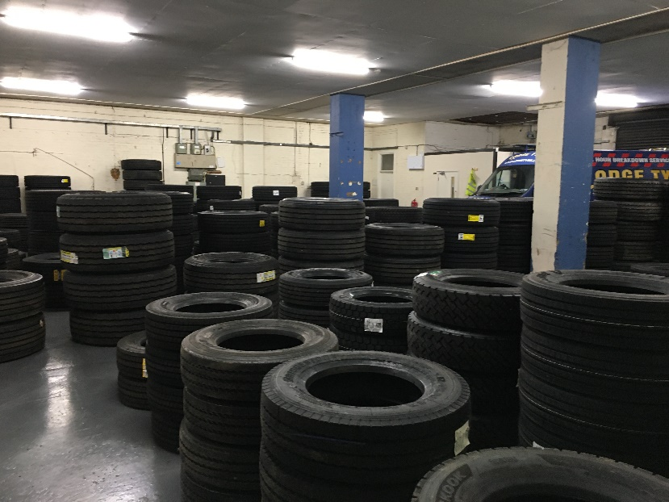
The large unit on Tinsley Industrial Estate, Shepcote Way has undergone a major internal refurbishment. New LED lighting, ceiling paneling and a lick of paint on the floor have left the warehouse, now full of stock, looking well organized and perfectly placed to provide the tyres & professional service you need to keep your fleet on the road. As you would expect from a Lodge Tyre Centre, our commercial tyre stock is second to none, but additionally this site has already seen a need to stock a great range of van tyres too – ideal if you are a smaller owner-driver.
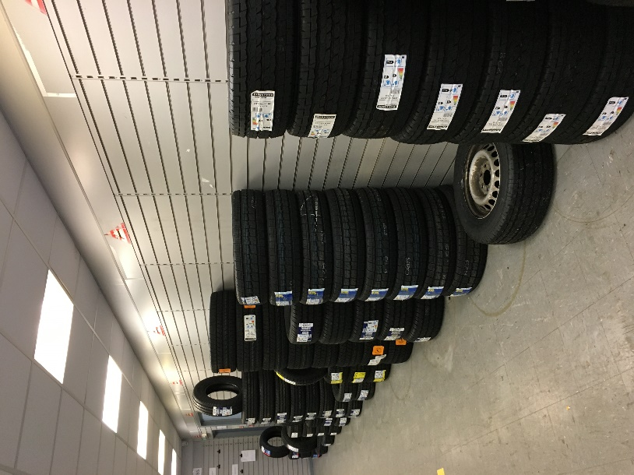
Staff have been carefully selected to ensure we cover the local area with knowledgeable, well-motivated, customer centric individuals motivated to provide exceptional Lodge Tyre service. Contact details for Centre Manager Neil and his team are on the branch finder page, or you can call him direct on 0114 551 8166. Alternatively, you can drop in and take advantage of the large yard in front of the store, but please ring for appointment first.
